**Bank Booking System**

**This system will help people to save their time by decreasing the time they wait, that they can book their appointments in the bank during our website .**

**The website contains an initial interface , this interface contains three banks (Cairo Amman Bank, Housing Bank ,** **Jordan Islamic Bank ) in Jordan , every bank has a private page to enter personal information and booking information .**

**\*\*** IF YOU WANT TO CHANGE THE LANGUAGE YOU CAN CLICK HERE FROM ARABIC TO ENGLISH



**How can we book an appointment?**

**We must follow this steps …**

**The First step (1)**

**Choose the bank you want**

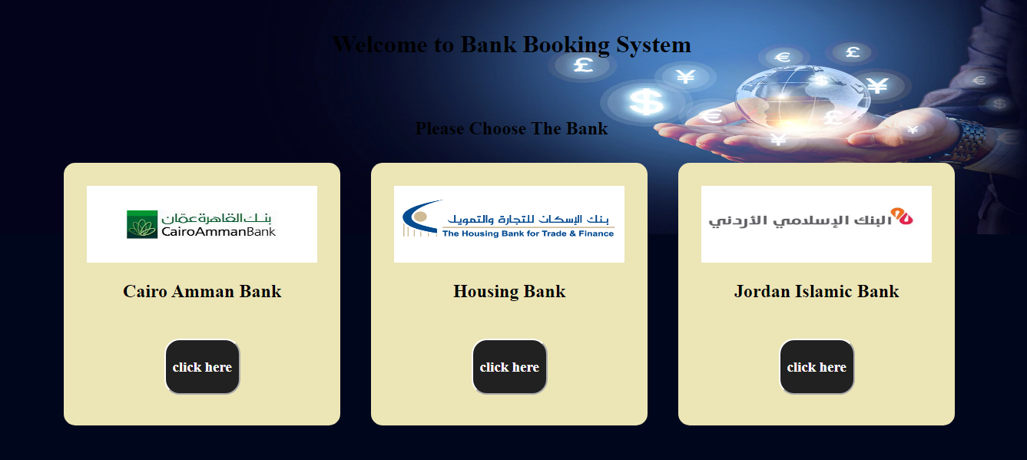

**- if you want Cairo Amman Bank booking click inside box contain this bank and if you want to show the official page of this bank click in image Cairo Amman Bank in box**

**- if you want Housing Bank booking click inside box contain this bank and if you want to show the official page of this bank click in image Housing Bank in box**

**- if you want Jordan Islamic Bank booking click inside box contain this bank and if you want to show the official page of this bank click in image Jordan Islamic Bank in box**

**------------------------------------------------------------------------------------**

**The Second step(2)**

**You will see the page for your selected bank**

**The first page contains the instructions, rules to follow, and a *booking information* box**

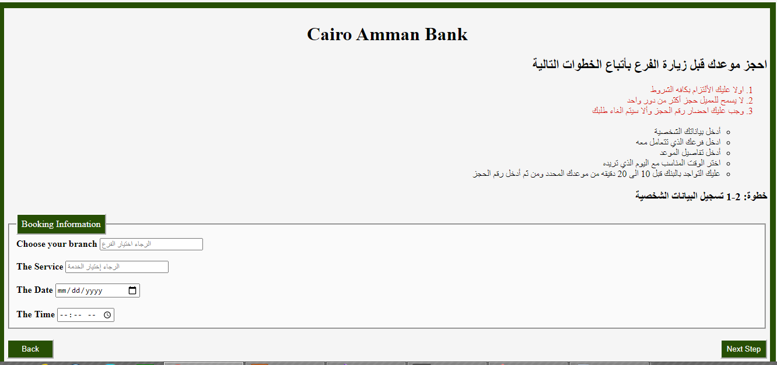

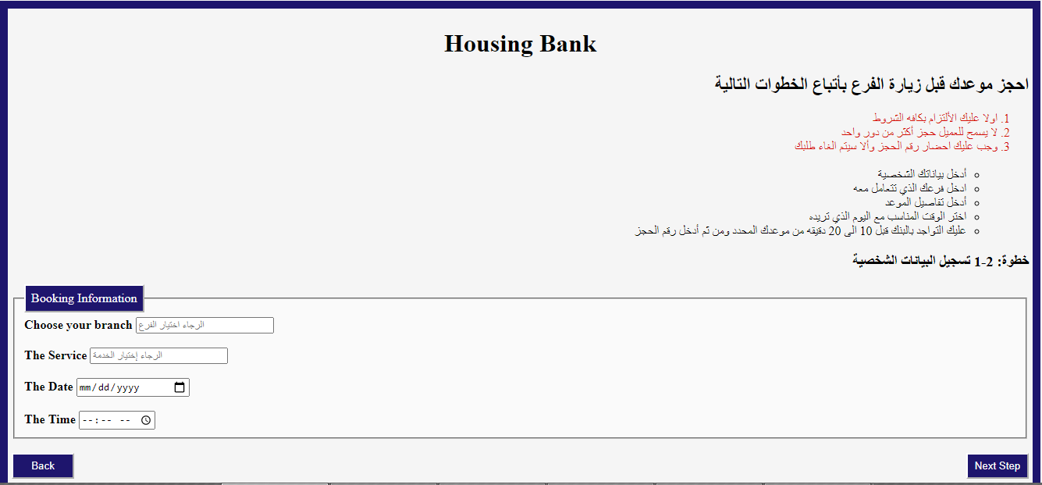 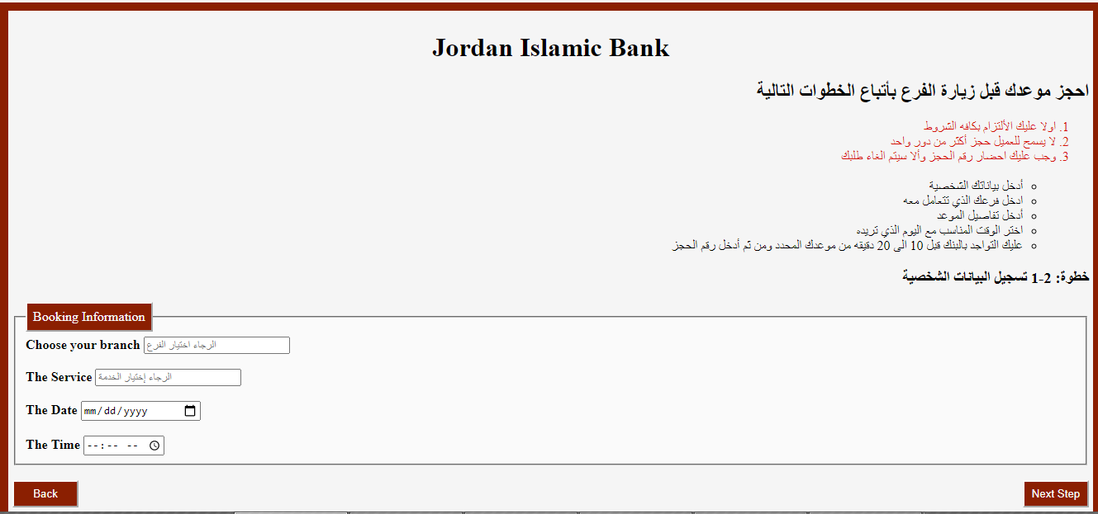

**In this box you will :**

**1- Choose your branch**

**2- Choose The Service**

**3- Choose The date ( Note : The date that you want to go bank in )**

**4- Choose The Time ( Note : The time in date you choose it , that you want to go bank )**

**------------------------------------------------------------------------------------**

**The Final step(3)**

**The second page contains *personal information*** **box**

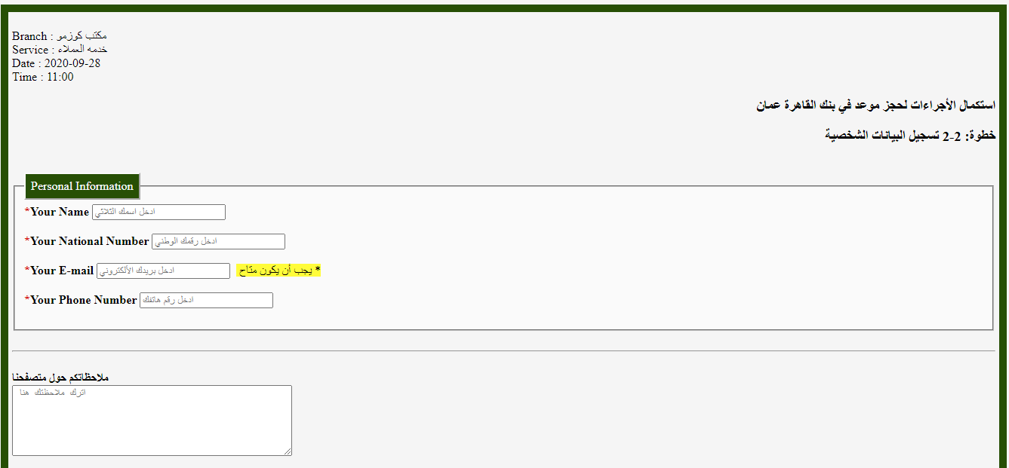

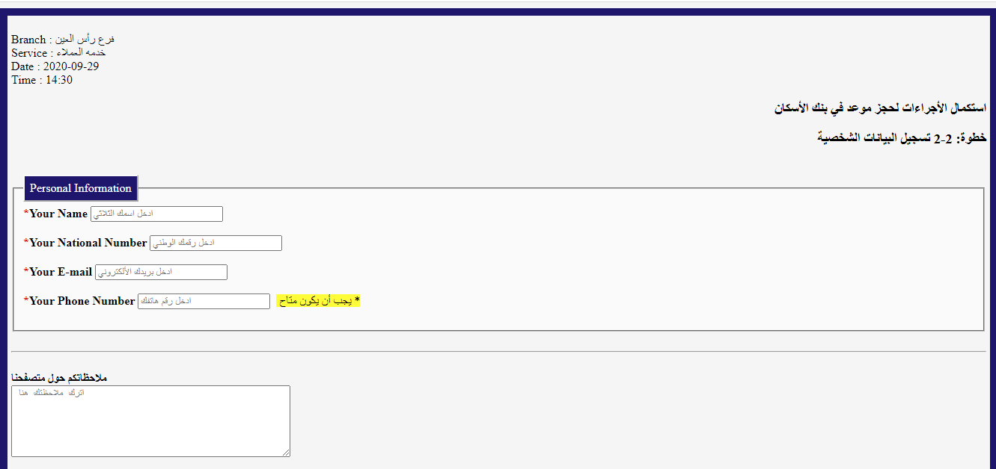

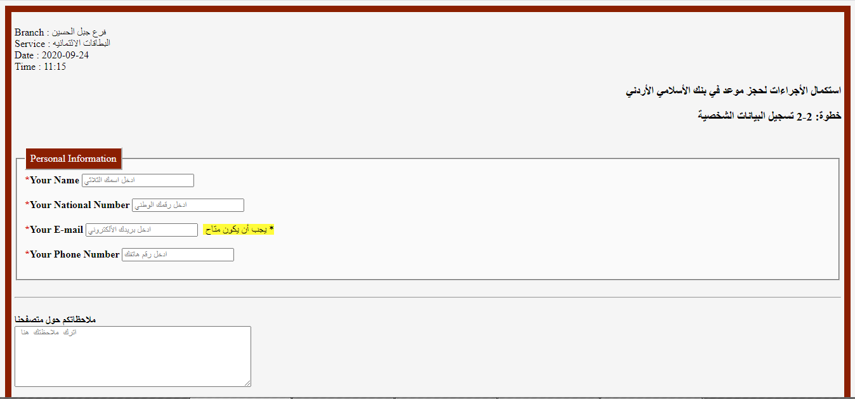 **In this box you will :**

**1- Enter Your Name ( Note : Triple Name )**

**2- Enter Your National Number**

**3- Enter Your E-mail ( Note : To send your request on it )**

**4- Enter Your Phone Number ( Note : To confirm your request on it Or to communicate with you )**

**\*\*** IF YOU HAVE ANY **Feedback** REGARDING THE WEBSITE YOU CAN WRITE IT IN NOTE BOX

If you followed the steps, you will see this page to confirm that your request has been successfully completed

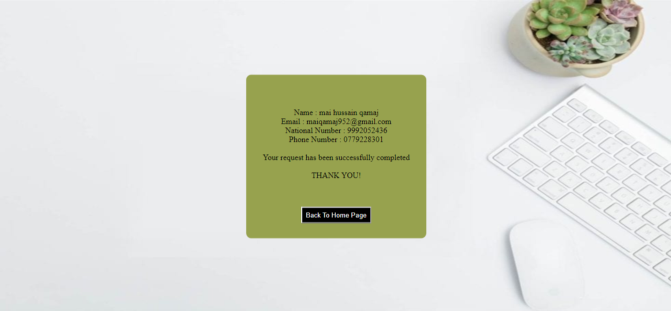

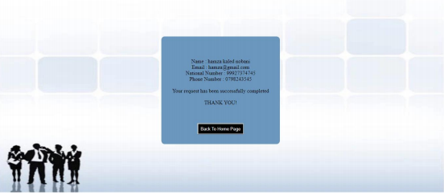

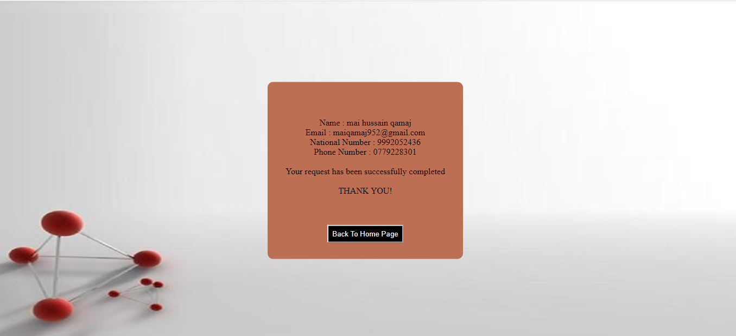

**BANK BOOKING SYSTEM TEAM**

***thank you all for booking with us***